Who Killed the Red Baron – Manual, Created

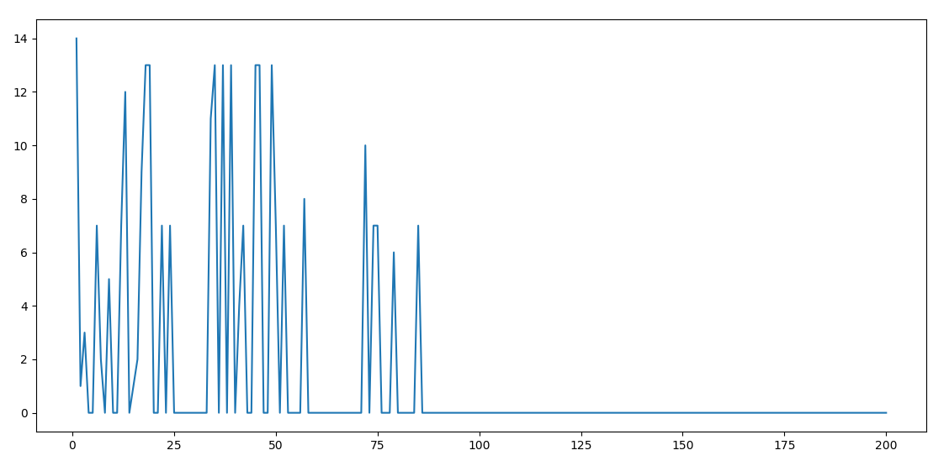

Deadliest Plane Crash – Manual and Generated

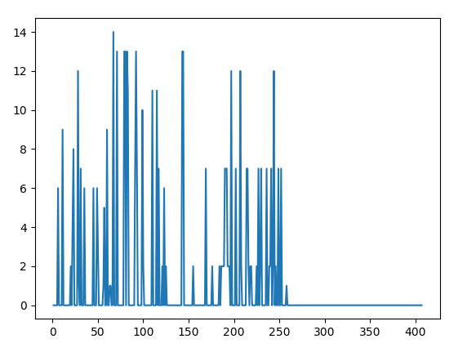

Deadliest Plane Crash – Manual,

